Workspace: A three in one application

Guided by:

Prof. Bhakti Raul

Submitted by:

1811020 : Jigyassa Lamba

1811030 : Sakshi Pandey

1811034 : Anina Pillai

Abstract

This report specifies the various processes and techniques used in designing, implementing and testing for the project on text editor , built as a desktop application using Python. The features of the current available text editors were analyzed and noted. This project aims to enhance those features and thus add more value to the current system.

This text editor named Workspace comes under the category of ‘desktop application’ i.e. it is a simple program that can be run on your laptop/PC without needing to use a browser.

Thus this text editor aims at providing some enhanced features , which make it stand out from some of the current available text editors like Notepad.Apart from providing the basic functionalities of a Notepad , it also supports enhanced features like Encryption/Decryption , Paint window and Journal application.

# Contents

1. **Introduction**

1.1Identification

1.2 Purpose

1.3 Scope

1.5 Overview and Restrictions

1. **Overall Description**

2.1 Product Perspective

2.2 Product Features

2.3 User Classes and Characteristics

2.4 Operating Environment

1. **Python Functionalities**

3.1 Basic Python

3.2 GUI Programming with Tkinter

3.3 Database Access

3.4 Libraries/Packages used

1. **Screenshots of the System**
2. **Link to User Manual**
3. **Working Demo**
4. **Conclusion**
5. **References**

# Introduction

A **text editor** is a type of computer program that edits plain text. Such programs are sometimes known as "**notepad**" software, following the naming of Microsoft Notepad. Text editors are provided with operating systems and software development packages, and can be used to change files such as configuration files, documentation files and programming language source code.

Identification

The desktop application being considered for development is referred to as Workspace.The end users of these applications will be a whole lot of persons who require text editors as a part of their job.

As this is the first project in its development , thus the version under development is version 1.0.

Purpose

The purpose is to design desktop applications which apart from providing basic functionalities of a basic text editor like creating , editing and saving a text document , it also provides smart functions like Encryption and Decryption to save sensitive and confidential data. Also apart from notepad, a paint functionality and a journal application has been added. A login and signup system has been added with the help of a database management system to make the application more secure.

Scope

As Workspace is developed as a desktop application only, so the scope is limited to the desktops and not as a web application. At a time only one person can log into the system and view or create his work.

Overview

Chapter 2 of this document describes the application under development from a holistic point of view. Functions ,characteristics, assumptions, dependencies and overall requirements are defined from application-level perspective.

Chapter 3 of this document describes the interfaces of the application being developed. They

Include the resources used to develop the application.

Chapter 5 of this document contains the screenshots of the desktop application. This chapter also contains the link to the user manual for further help.

Chapter 6 of this document concludes the whole desktop application.The main aim of the conclusion is to restate the main argument. It reminds the reader of the strengths of main argument(s) and reiterates the most important evidence supporting those argument(s).

Chapter 7 of this document contains the references used while building this application.Referencing allows you to acknowledge the contribution of other writers and researchers in your work. Referencing is also a way to give credit to the writers from whom you have borrowed words and ideas.

# 

# 

# Overall Description

This chapter provides an overall description of the desktop application.

Product Perspective

The product is a full screen text editor for windows operating system with the capabilities to create and edit files with functions like encryption and decryption . Also it has the capability to use paint windows for creating simple and colorful drawings. Along with it , it also has a journal feature to store your daily tasks as a reminder .

Product Features

Workspace provides the following functionalities:

1.**Login/Register**

In computer security, logging in (or logging on, signing in, or signing on) is the process by which an individual gains access to a computer system by identifying and authenticating themselves. The user credentials are typically some form of "username" and a matching "password", and these credentials themselves are sometimes referred to as a login (or a logon or a sign-in or a sign-on).

**Operations:**

* Login
* Sign Up / Create Account

2. **Notepad**

Notepad is a basic text editor used for editing existing text documents and creating new one.

**Operations:**

* **File Operations:** Basic file operations include:

1. Create a new file
2. Open existing file
3. Save and Save As a file
4. Delete a file
5. Exit from the editor
6. Switch to a different application.

* **Editing Operations**: Editing operations include the following functions:

1. Cut, copy and paste
2. Clear All
3. Find and Replace

* **Display Operations**: These operations include options to change the view of the output screen of the text editor. These include:

1. View
2. Theme

* **Special Operations** : Special operations are the operations which make Workspace a smart text editor. These include:

1. Encryption
2. Decryption

* **Font Operations** : These include various functions that can be used to change the font properties.

1. Font Style Tab
2. Font Size Tab
3. Bold/Underline/Italic
4. Text Alignment (Left/Center/Right)
5. Font Color

3. **Paint**

Workspace also provides you with the paint functionality. It is a simple raster graphics editor used for creating simple and colorful drawings.

**Operations:**

* **File Operations:** The basic file operations include:

1. Save

2. Clear Screen

* **Drawing Tools:** These include the basic tools used for drawing.

1. Brush
2. Color window

* **Editing Tools :** Editing Tools include:

1. Eraser
2. Size scroll bar( For changing the tip of the brush for a bold or fine effect)

4. **Encryption/Decryption using AES-256 Cipher**

Workspace provides you with the functionality to store data privately and maintain confidentiality in the Notepad app encryption/decryption feature. It makes use of the AES-256 cipher to do so. Users can encrypt their files using a unique password and they can use it to decrypt the file. AES-256 is a solid symmetric cipher that is commonly used to encrypt data for oneself. In other words, the same person who is encrypting the data is typically decrypting it as well (think password manager).

**Encryption:**

This function uses the password to encrypt the plain text. Therefore, anyone with access to the encrypted text and the password will be able to decrypt it.

The encryption function makes use of:

1. Nonce: A random nonce (arbitrary value) must be a random and unique value for each time our encryption function is used with the same key. It is basically a random salt for a cipher.
2. Scrypt: Scrypt is used to generate a secure private key from the password. This will make it harder for an attacker to brute-force our encryption.
3. Salt: A new random salt is used for each run of our encryption. This makes it impossible for an attacker to use precomputed hashes in an attempt to crack the cipher.
4. Scrypt parameters:

* N is the cost factor. It must be a power of two, and the higher it is the more secure the key, but the more resources it requires to run.
* R is the block size.
* P is the parallelization factor, useful for running on multiple cores.

1. Base64: We encode all of our bytes-type data into base64 a convenient string representation
2. Tag: The tag is used to authenticate the data when using AES in GCM mode. This ensures no one can change our data without us knowing about it when we decrypt.

**Decryption:**

The decryption function needs the same salt, nonce, and tag that we used for encryption. We used a dictionary for convenience in parsing, but if we instead wanted one string of cipher text we could have used a scheme like salt.nonce.tag.cipher_text. The configuration parameters on the Scrypt and AES functions need to be the same as the encrypt function.

4. **Journal**

Journal Application enables you to store your tasks with date and time. You can add as well as delete tasks. All the tasks will be stored in your account, so need to worry about privacy.

**Operations:**

* **File Operations:** The basic file operations include:

1. Add Entry
2. Edit Entry
3. Delete
4. Switch between Applications
5. LogOut

User Classes and Characteristics

There can be several users of Workspace, text editor. They are categorised on the basis of their need . These are:

1. People who need a daily task manager : This category of people will require the journal application for their use.
2. People who need a pictorial representation: This category of people will require the paint application for their use.
3. People who need a text editor to store and edit documents : This category of people will require a notepad application to create , store and edit their documents.

Operating Environment

The operating environment of Workspace are listed below:

* Operating System : Windows 10
* Database : sqlite3
* Front-end : Tkinter (Python Module)
* Backend : Python

# 

# Python Functionalities

This chapter includes the python resources used to develop the desktop application.

Basic Python

Python is an interpreted, object-oriented, high-level programming language with dynamic semantics. Its high-level built in data structures, combined with dynamic typing and dynamic binding, make it very attractive for Rapid Application Development, as well as for use as a scripting or glue language to connect existing components together. Python's simple, easy to learn syntax emphasizes readability and therefore reduces the cost of program maintenance. Python supports modules and packages, which encourages program modularity and code reuse. The Python interpreter and the extensive standard library are available in source or binary form without charge for all major platforms, and can be freely distributed

GUI Programming - Tkinter

Tkinter is the standard GUI library for Python. Python when combined with Tkinter provides a fast and easy way to create GUI applications. Tkinter provides a powerful object-oriented interface to the Tk GUI toolkit.

Creating a GUI application using Tkinter is an easy task. All you need to do is perform the following steps −

* Import the *Tkinter* module.
* Create the GUI application main window.
* Add one or more of the above-mentioned widgets to the GUI application.
* Enter the main event loop to take action against each event triggered by the user.

**Tkinter Widgets**

Tkinter provides various controls, such as buttons, labels and text boxes used in a GUI application. These controls are commonly called widgets.

There are currently 15 types of widgets in Tkinter.

Database Access

The Python programming language has powerful features for database programming. Python supports various databases like MySQL, Oracle, Sybase, PostgreSQL, etc. Python also supports Data Definition Language (DDL), Data Manipulation Language (DML) and Data Query Statements. For database programming, the Python DB API is a widely used module that provides a database application programming interface.

Libraries/Packages Used

1. **Pillow:** The Python Imaging Library adds image processing capabilities to your Python interpreter. This library provides extensive file format support, an efficient internal representation, and fairly powerful image processing capabilities. The core image library is designed for fast access to data stored in a few basic pixel formats. It should provide a solid foundation for a general image processing tool. We have used this library for the ‘Save File’ feature in Paint.
2. **PyCryptodome:** PyCryptodome is a self-contained Python package of low-level cryptographic primitives. We used it in this project to implement the AES-256 Cipher in Python.
3. **Ghostscript:** Ghostscript is a suite of software based on an interpreter for Adobe Systems’ PostScript. Its main purposes are the rasterization and rendering of such page description language files, for the display or printing of document pages, and the conversion between PostScript and PDF files or Image Files. We use it in our project in the ‘Save File’ feature in Paint. We initially save the drawing canvas content as a PostScript File(.eps) and then use GhostScript to interpret it and convert it to a .png file.

**Benefits of Python for database programming**

There are many good reasons to use Python for programming database applications:

* Programming in Python is arguably more efficient and faster compared to other languages.
* Python is famous for its portability.
* It is platform independent.
* Python supports SQL cursors.
* In many programming languages, the application developer needs to take care of the open and closed connections of the database, to avoid further exceptions and errors. In Python, these connections are taken care of.
* Python supports relational database systems.
* Python database APIs are compatible with various databases, so it is very easy to migrate and port database application interfaces.

# Screenshots of the System

Following are the screenshots of Workspace, our desktop application:

1. Login/Register

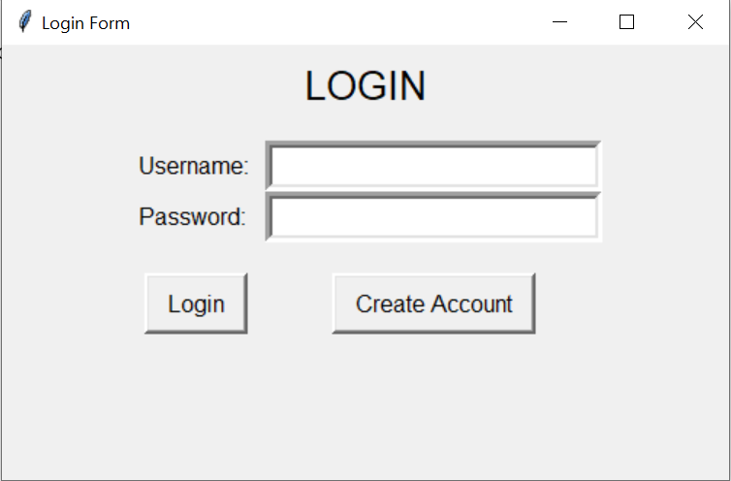

1. Menu Bar Options

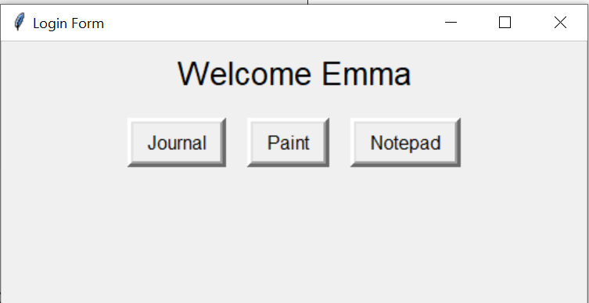

1. Notepad

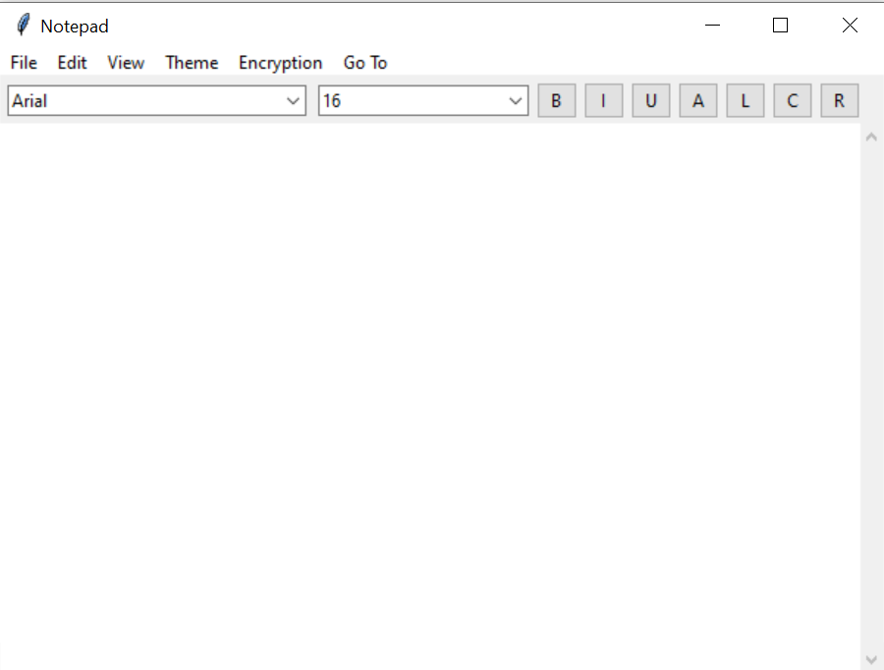

1. Encryption and Decryption

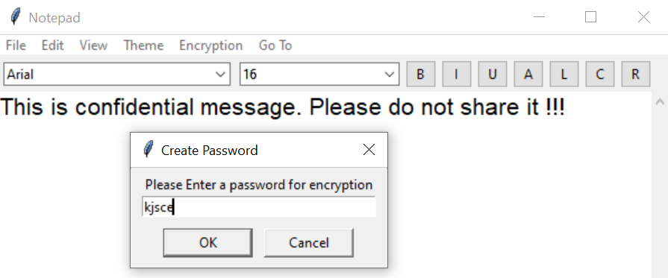

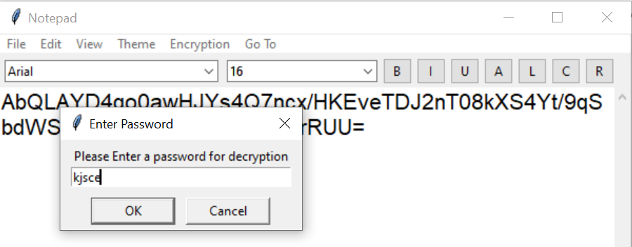

1. Paint

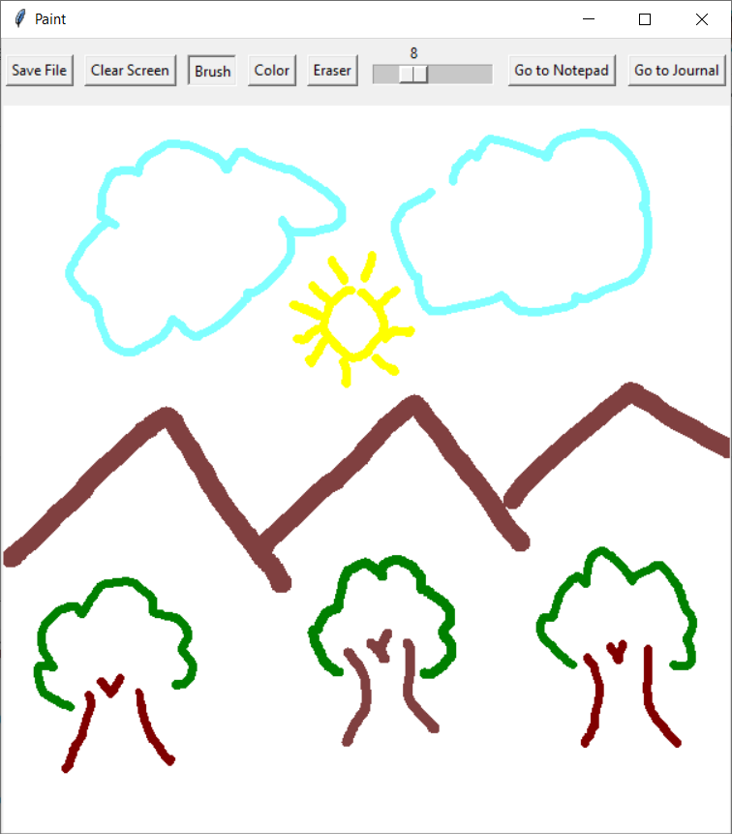

1. Journal

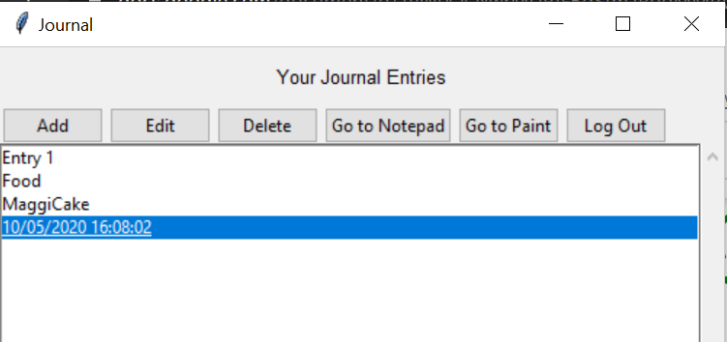

1. Add an Entry in the Journal

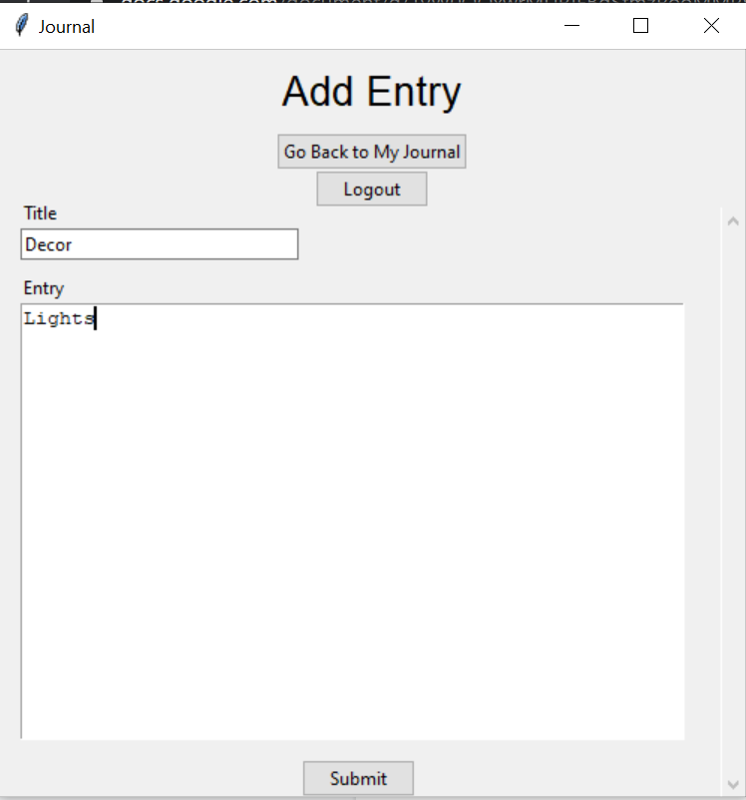

1. Edit entry in Journal:

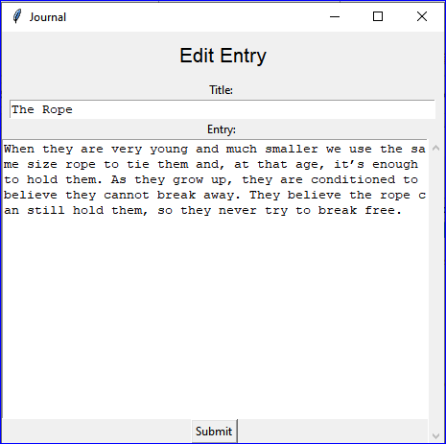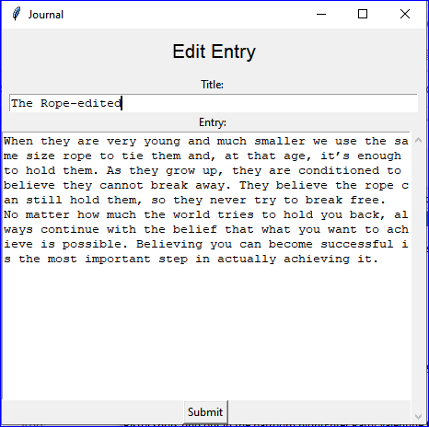

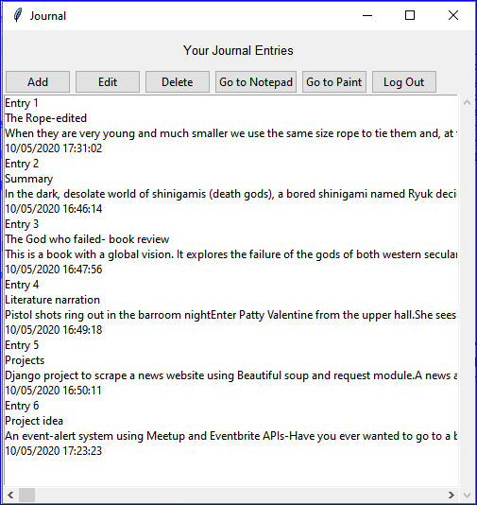

9.Delete entry from the journal:

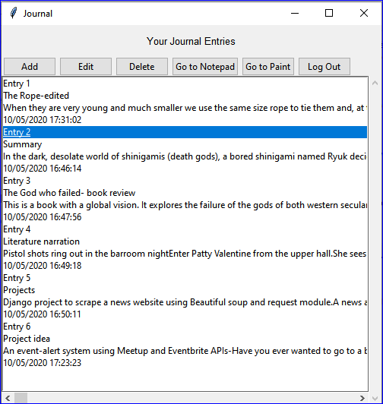

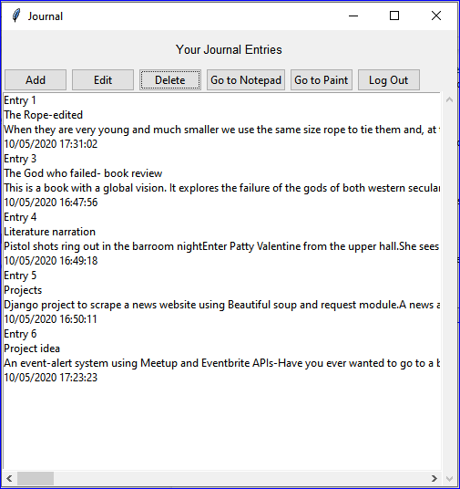

# 

# Link to User Manual

For a detailed description of various functionalities please refer the following link to the user manual:

[USER MANUAL Python](https://docs.google.com/document/d/1LdgY1ZZUIRn6PmGC436N0veKylZUyKWu4a_pkZJxp3c/edit?usp=sharing)

# Working Demo

Notepad: <https://drive.google.com/open?id=1KhFHr0POrpcdDLyxmiYjFrjdDchQ2dEf>

Paint : <https://drive.google.com/file/d/1ZO24JblKM35Pim56SlFh658SjmF6Rlel/view?usp=sharing>

Journal : <https://drive.google.com/open?id=1mzlh8hAd1YntmXnD1AnCVU5tID2fH7YJ>

# Conclusion

Workspace, a smart text editor was developed with the help of python. Various different functionalities were added to enhance its performance. Thus while developing this we learnt the hands on experience with Python, Tkinter which is a module of Python and Database Connectivity with python. Different kinds of users can use it for different purposes , be it storing secure information, maintaining a daily record of your tasks or simply drawing simple and colorful drawings using the paint window.

# References

1. [Wikipedia, the free encyclopedia](https://en.wikipedia.org/)
2. [GeeksforGeeks | A computer science portal for geeks](https://www.geeksforgeeks.org/)
3. [https://www.tutorialspoint.com/](https://www.tutorialspoint.com/index.htm)
4. [Real Python: Python Tutorials](https://realpython.com/)
5. [Stack Overflow - Where Developers Learn, Share, & Build Careers](https://stackoverflow.com/)
6. [Hacker Noon](https://www.hackernoon.com/)
7. [Javatpoint: Tutorials List](https://www.javatpoint.com/)
8. <https://www.youtube.com/>